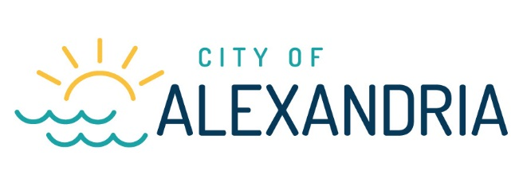
Rental Registration – Related Items

DEFINITIONS

Rental Unit or Residential Rental Unit – Any house, apartment, condominium, townhouse, room, or group of rooms, constituting or located within, a dwelling and forming a single habitable unit which is leased or rented for occupancy for a period of not less than thirty (30) days, but not including private/vacation home rental, bed and breakfast, resort, hotel, or motel.

NOTE: Sleeping rooms that are rented individually are each considered as a separate rental unit.

MINNESOTA COURT OF APPEALS RULING
The Minnesota Court of Appeals has ruled (Beaumia vs. Eisenbraun, Minn. 2007) that a landlord’s failure to comply with the registration requirements of a City Residential Rental Registration Ordinance nullifies any lease agreement the landlord may have with a tenant and relieves the tenant of any obligation to pay rent.

BACKGROUND CHECK AUTHORIZED
A state law known as the Kari Koskinen Manager Background Check Act (Minn. Stat. Sections 299C.66 to 299C.71) requires that before hiring a property manager, a landlord must conduct a background check on the potential manager. For the purposes of this law, a manager is defined as any individual who is hired or is applying to be hired by an owner and who has or would have the means, within the scope of the individual's duties, to enter tenants' dwelling units, but a manager is not a person who is hired on a casual basis and not in the ongoing course of the business of the owner. If the background check reveals that the manager has been convicted of a background check crime defined in Minn. Stat. Section 299C.67, subd. 2, paragraph (a), the landlord may not hire the manager or, if the manager was hired pending completion of the background check, shall terminate the manager's employment. This law also imposes other background check rights and obligations on landlords, tenants, and property managers.

Please use the following link to access information for requesting background checks:

https://dps.mn.gov/divisions/bca/pages/background-checks.aspx

HUD SECTION 8
If you are registering a unit or units that are eligible for the reduced ($7.50) annual registration fee as being Section 8 eligible, you must attach a copy of your current contract (or addendum to a contract) with the Douglas County HRA for those units.

NOTE
Please know that these materials are summaries only and are not intended to be a full recitation of all laws, ordinances, rules, and regulations that apply to landlords and tenants in Alexandria, Minnesota. Familiarize yourself with these laws, ordinances, rules, and regulations, and if you have any questions about them, you should consult with your own attorney for advice. Also note the granting of the registration certificate is not certification of zoning compliance. Rental registration application and certification is subordinate to the City’s Zoning Ordinance.

Visit the office of the Minnesota Attorney General for more information:
http://www.ag.state.mn.us/consumer/Handbooks/LT/default.asp

“Minnesota Statute 504B.181 requires landlords to notify residential tenants that this
handbook is available to them.”

