boundary/partition fence permit application

704 Broadway | Alexandria, MN 56308
Phone (320) 763-6678 | Fax (320) 763-3511
www.alexandriamn.city

Permit #  _______________________ | Date Received _____/______/______  Date Approved _____/______/______ | PIN 63-_________-________  Date Fee Paid ___________

APPLICANT NAME(S) WORK # CELL # EMAIL ADDRESS

APPLICANT ADDRESS CITY STATE ZIP

ADDRESS/SITE WHERE PROJECT IS LOCATED _______

APPLICANT OWNS THE PROPERTY AS: FEE TITLE CONTRACT FOR DEED

SAMPLE TYPES OF FENCES
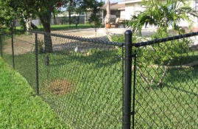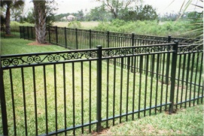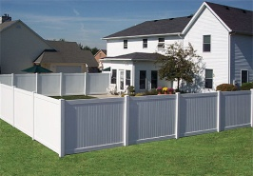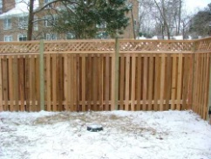

TYPE OF MATERIAL FROM WHICH YOUR FENCE IS TO BE CONSTRUCTED:

CHAIN LINK WROUGHT IRON ____VINYL ______ BOARD & PICKET

______ OTHER, PLEASE SPECIFY ___________________________________

ENCLOSURES:
□ CERTIFICATE OF SURVEY □ SITE PLAN SHOWING LOCATION OF FENCE

NOTE:
Survey & Inspections Required and Applicant Acknowledgement & Signature (see over)
A valid Certificate of Survey is required. Attach the survey to this application.
The property lines/corners matching the survey must be marked and accessible.

SEE OVER FOR ADDITIONAL INFORMATION

TYPES OF FENCING NOT REQUIRING A PERMIT
Ornamental and/or privacy fences (not designed or serving as a boundary or partition fence) and enclosing only a limited portion (25% or less) of a side yard, rear yard or front yard, are allowed without requiring a permit. Ornamental fences includes such things as split rail, picket, and brick wall fences, but not such things as chain link fences. The maximum allowed height for an ornamental brick wall is three (3) feet, for a split rail, picket or wrought iron fence four (4) feet, and for a privacy fence around a patio, hot tub, pool, etc., six (6) feet.

SURVEY & INSPECTIONS REQUIRED
All fence permit applications shall include a Certificate of Survey showing/labeling the following:
• Property address and/or legal description (if platted).
• Adjacent street(s) and street names.
• Property lines and property line dimensions.
• Existing objects and/or structures located near the proposed fence or property lines.

Before a site inspection is conducted by the designated City official, the following items shall be located on-site as shown on the Certificate of Survey (or on a site plan based on the Certificate of Survey) and clearly marked with paint, flags, stakes, and/or laths:
• Property corners.
• Boundary lines.
• Proposed fence location.

Two site inspections are required:
• 1st Inspection (Staking): Verification of property lines corners/lines and proposed fence location.
• 2nd Inspection (Final): Final review of project.

APPLICANT ACKNOWLEDGMENT & SIGNATURE
This permit becomes null and void if work or construction authorized is not commenced within 180 days,
or if construction or work is suspended or abandoned for a period of 180 days at any time after work has commenced. I hereby certify that I have read and examined this application and know the same to be true
and correct. All provisions of laws and ordinances governing this type of work will be compiled with whether specified herein or not. The granting of a permit does not presume to give authority to violate or cancel the provisions of any other state or local law regarding construction or the performance of construction.

SIGNATURE: ___________________________________________________________ DATE ________

APRROVED BY: ___________________________________________________________ DATE _________
ZONING ADMINISTRATOR

